Creamy Hummus

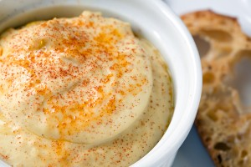
- 1 cup dried chickpeas (garbanzo beans)
- 4 cups water
- 2 inches kelp
- 1 & 1/2 tsp. sea salt
- 3 heaping tbsp. sesame tahini
- 1/3 cup olive oil
- 1/2 tsp. cumin
- 2 shakes of coriander
- 3 garlic cloves, peeled
- 1/8 tsp. freshly ground black pepper
- Juice of 1 lemon
- Smoked Paprika
Soak chickpeas in water for 8-10 hours or overnight. Discard soaking water. Bring chickpeas plus 4 cups fresh water to a boil. Discard the foam that rises to the top. Add kelp, cover and lower the heat to simmer. Cook 1 hour. Add 1 tsp. sea salt and continue cooking 35-40 minutes or until chickpeas are soft. Drain chickpeas, but reserve 1/2 cup of the cooking water. In a food processor combine cooked chickpeas, kelp, sesame tahini, olive oil, cumin, coriander, garlic, 1/2 tsp. sea salt, black pepper and lemon juice. Puree until smooth and creamy. Add chickpea water and puree again to achieve a lighter hummus consistency. Top with a light dusting of smoked paprika for some extra zing

